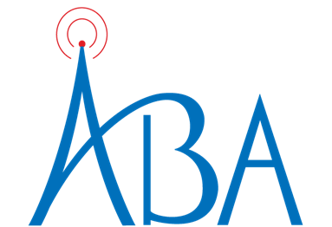

To: Alabama TV and Radio Stations
Fr: Sharon Tinsley, President, Alabama Broadcasters Association
Re: New PEP client! Auburn University (multiple campaigns)
Dt: October 1, 2023

Auburn University, as a state entity, has become a PEP client for the sole purpose of raising awareness of their contributions to the well-being of the state, including the work force and economy in Alabama. They are launching with a set of spots titled, “Auburn Works”. In mid-December, they are substituting in a brief campaign titled, “Auburn Value.” They are likely to make other substitutions throughout their current PEP agreement which ends in June, 2024.

Contact Tina Kunze at 205-982-5001 or tkunze@al-ba.com with questions.

Auburn University
“Auburn Works”
AIR DATES:
October 1, 2023 - December 15, 2023
Reinstate January 15, 2024 - UFN

“Auburn Value”
AIR DATES:
December 15, 2023 - January 15, 2024

