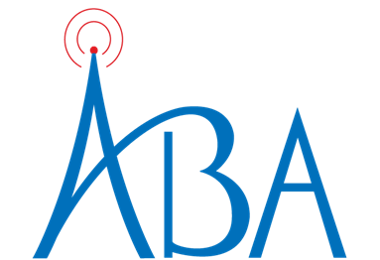

To: Alabama Radio Stations
Fr: Sharon Tinsley, President, Alabama Broadcasters Association
Re: Dolly’s Imagination Library (Alabama Dept of Early Childhood Education)
Dt: March 1, 2025

Okay – I’ve not been this excited in a LONG time!!! Dolly Parton’s Imagination Library is NOW available to children in Alabama! Between the three of us in the ABA office, we have 10 grandchildren and one on the way!!! Dolly will send FREE books to children from birth through age five. Go to imaginationlibrary.com to sign up your eligible children and grandchildren! It’s possible if you have grandchildren in another state (like me), they are eligible there, too! Check it out!

Alabama’s Dept of Early Childhood Education is using the ABA’s PEP program to let everyone know this FREE service is now available in our state. Help us spread this GREAT NEWS! There are 30 and 60 second spots for radio.

Contact Tina Kunze at 205-982-5001 or tkunze@al-ba.com with questions.

Thank you!
Sharon

AL Dept of Early Childhood Education
“Dolly’s Imagination Library”

:30
ALDECE Dolly’s Imagination Library 25 30R ISCI: DECE2101

:60
ALDECE Dolly’s Imagination Library 25 60R ISCI: DECE3101

Air dates:
March 1, 2025 – Feb 28, 2026

